**DIGITAL SIGNAL PROCESSING LAB EXPT.1**

**GENERATION AND OPERATION OF ELEMENTARY SIGNALS**

**NIKHIL ROUT**

**22BEC1020**

**AIM: To generate the following Elementary Digital Signals:**

**➢ Discrete Unit Impulse Sequence and Delayed Discrete Unit Impulse Sequence**

**➢ Discrete Unit Step Sequence**

**➢ Discrete Unit Ramp Sequence**

**➢ Discrete Real Exponential Sequences when α < 1, 0 < α < 1, -1 < α < 1, α = 1 and α = -1**

**➢ To perform five operations on any Generated Sequences (Operations on Dependent and Independent Variables):**

**(i) Addition**

**(ii) Multiplication**

**(iii) Differentiation with respect to time**

**(iv) Amplitude Scaling**

**(v) Amplitude Shifting**

1. **DISCRETE UNIT IMPULSE SEQUENCE**

clc

clear all

close all

n = -10:10;

N3 =21;

d = [zeros(1,(N3-1)/2),ones(1,1),zeros(1,(N3-1)/2)];

stem(n, d, 'linewidth',2);

set(gca,'fontsize',13,'fontweight','bold');

xlabel('Number of Samples, n','fontsize', 12, 'fontweight','bold');

ylabel('Amplitude, \delta[n]', 'fontsize', 12, 'fontweight', 'bold');

title('Discrete Unit Impulse Sequence', 'fontsize', 14);

grid on;

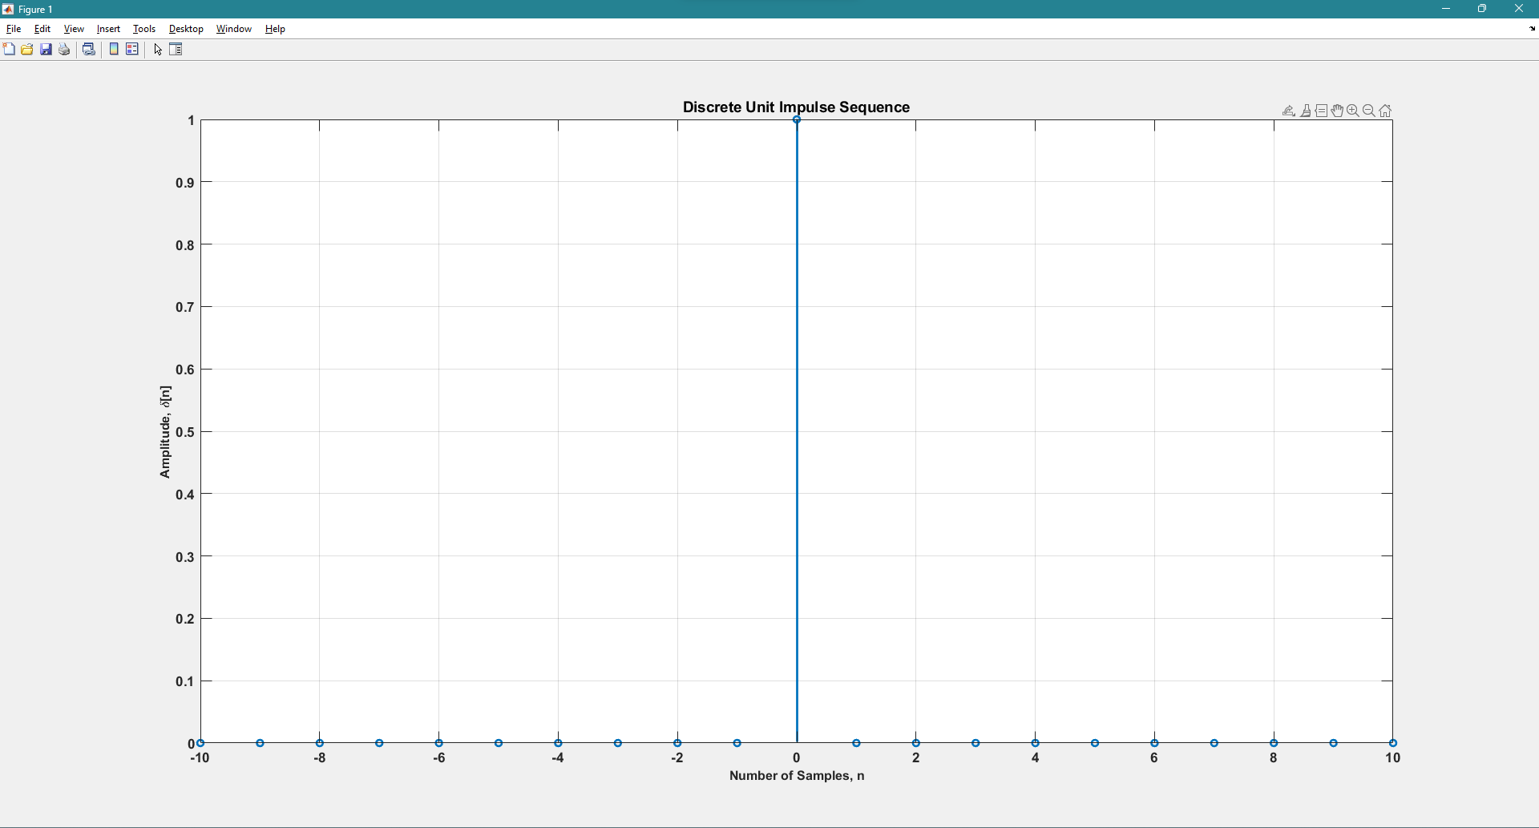

1. **DISCRETE UNIT IMPULSE SEQUENCE WITH DELAY**

clc

clear all

close all

n = -10:10;

N3 =21;

delay = 2; %22BEC1020

d = [zeros(1,(N3-1)/2),ones(1,1),zeros(1,(N3-1)/2)];

stem(n+delay, d, 'linewidth',2);

set(gca,'fontsize',13,'fontweight','bold');

xlabel('Number of Samples, n','fontsize', 12, 'fontweight','bold');

ylabel('Amplitude, \delta[n]', 'fontsize', 12, 'fontweight', 'bold');

title('Discrete Unit Impulse Sequence with Delay', 'fontsize', 14);

grid on;

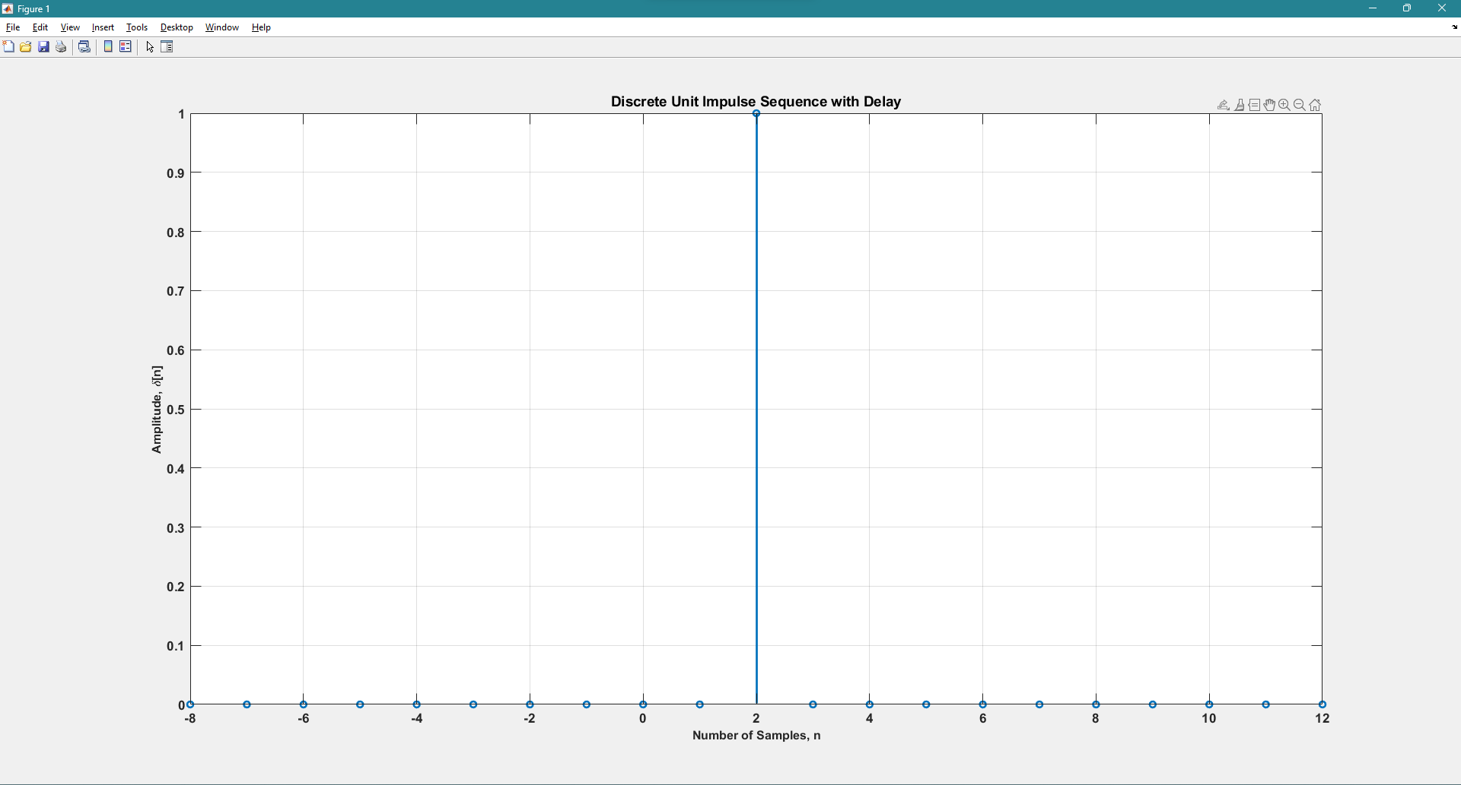

1. **DISCRETE UNIT STEP SEQUENCE**

clc

clear all

close all

amp = 1;

n = -10:10;

d = (n>=0);

stem(n, d*amp, 'linewidth',2);

set(gca,'fontsize',13,'fontweight','bold');

xlabel('Number of Samples, n','fontsize', 12, 'fontweight','bold');

ylabel('Amplitude, \delta[n]', 'fontsize', 12, 'fontweight', 'bold');

title('Discrete Unit Step Sequence', 'fontsize', 14);

grid on;

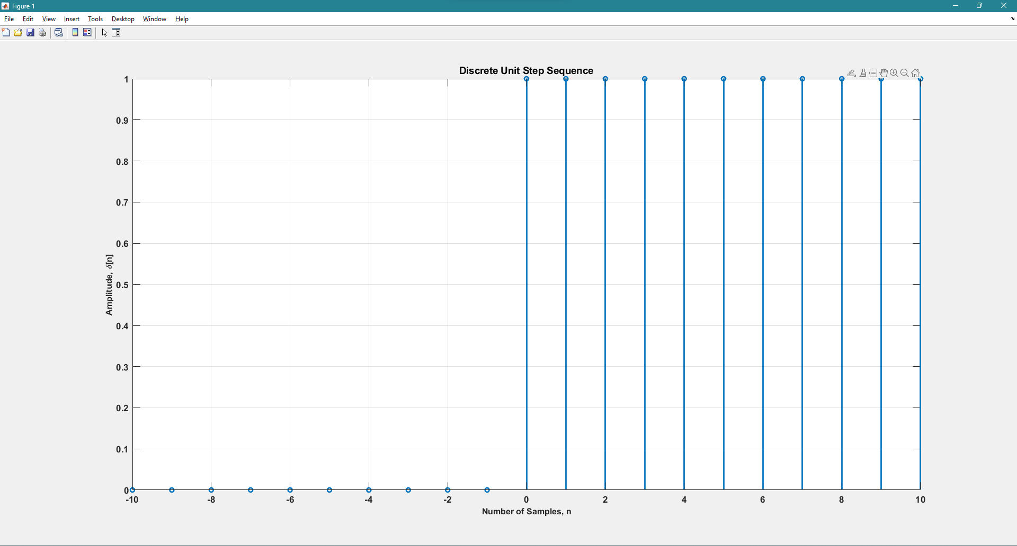

1. **DISCRETE RAMP SEQUENCE**

clc

clear all

close all

n = -2:10;

d = (n>=0);

stem(n, d.*n, 'linewidth',2);

set(gca,'fontsize',13,'fontweight','bold');

xlabel('Number of Samples, n','fontsize', 12, 'fontweight','bold');

ylabel('Amplitude, \delta[n]', 'fontsize', 12, 'fontweight', 'bold');

title('Discrete Ramp Sequence', 'fontsize', 14);

grid on;

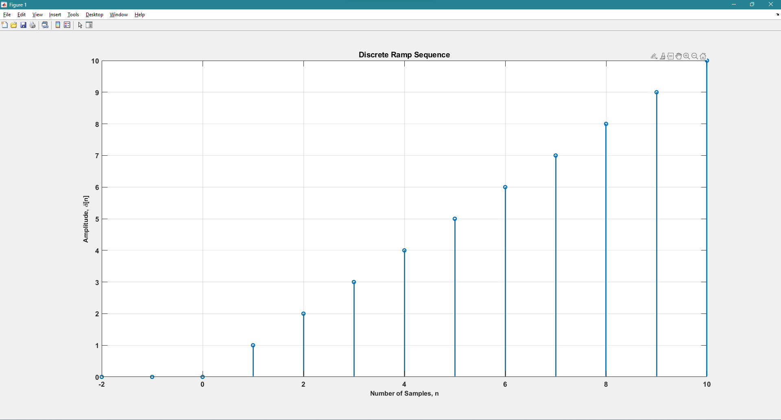

1. **DISCRETE EXPONENTIAL SEQUENCES WHEN α < 1, 0 < α < 1, -1 < α < 1, α = 1 and α = -1**

clc

clear all

close all

subplot(5,1,1);

n=-10:10;

a=-3;

d=a.^n;

stem(n,d,'linewidth',2);

set(gcs,'fontsize',13,'fontweight','bold');

xlabel('Number of Samples,n','fontsize',5,'fontweight','bold');

ylabel('Amplitude,\delta[n]','fontsize',5,'fontweight','bold');

title('Discrete Unit Impulse Sequence(a < -1)','fontsize',9);

grid on;

subplot(5,1,2);

n=-10:10;

a=0.8;

d=a.^n;

stem(n,d,'linewidth',2);

set(gcs,'fontsize',13,'fontweight','bold');

xlabel('Number of Samples,n','fontsize',5,'fontweight','bold');

ylabel('Amplitude,\delta[n]','fontsize',5,'fontweight','bold');

title('Discrete Unit Impulse Sequence(0 < a < 1)','fontsize',9);

grid on;

subplot(5,1,3);

n=-10:10;

a=0.4;

d=a.^n;

stem(n,d,'linewidth',2);

set(gcs,'fontsize',13,'fontweight','bold');

xlabel('Number of Samples,n','fontsize',5,'fontweight','bold');

ylabel('Amplitude,\delta[n]','fontsize',5,'fontweight','bold');

title('Discrete Unit Impulse Sequence(-1 < a < 1)','fontsize',9);

grid on;

subplot(5,1,4);

n=-10:10;

a=-1;

d=a.^n;

stem(n,d,'linewidth',2);

set(gcs,'fontsize',13,'fontweight','bold');

xlabel('Number of Samples,n','fontsize',5,'fontweight','bold');

ylabel('Amplitude,\delta[n]','fontsize',5,'fontweight','bold');

title('Discrete Unit Impulse Sequence(a = -1)','fontsize',9);

grid on;

subplot(5,1,5);

n=-10:10;

a=1;

d=a.^n;

stem(n,d,'linewidth',2);

set(gcs,'fontsize',13,'fontweight','bold');

xlabel('Number of Samples,n','fontsize',5,'fontweight','bold');

ylabel('Amplitude,\delta[n]','fontsize',5,'fontweight','bold');

title('Discrete Unit Impulse Sequence(a = 1)','fontsize',9);

grid on;

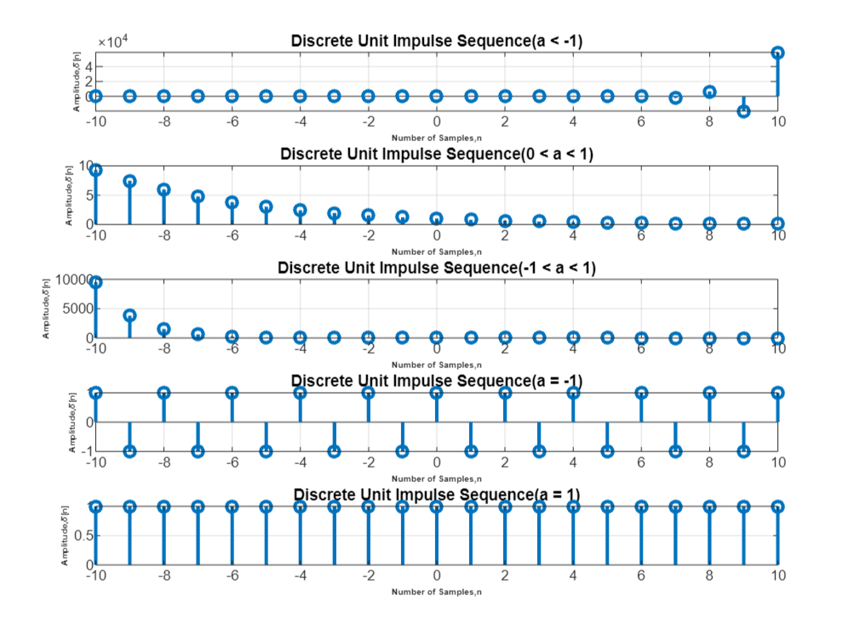

1. **SINE WAVE GENERATION AND ITS DIFFERENTIATION WITH RESPECT TO TIME**

clc

clear all

close all

syms t;

t1=0:0.3:2*pi;

x=sin(t);

subplot(2,1,1);

stem(t1,subs(x,t1),'linewidth',2);

set(gcs,'fontsize',13,'fontweight','bold');

xlabel('Number of Samples,n','fontsize',12,'fontweight','bold');

ylabel('Amplitude,\delta[n]','fontsize',12,'fontweight','bold');

title('Sine Wave Sequence','fontsize',14);

grid on;

y=diff(x,t);

t=0:0.3:2*pi;

subplot(2,1,2)

stem(t,subs(y,t),'linewidth',2);

set(gcs,'fontsize',13,'fontweight','bold');

xlabel('Number of Samples,n','fontsize',12,'fontweight','bold');

ylabel('Amplitude,\delta[n]','fontsize',12,'fontweight','bold');

title('Differentiated Sine Wave Sequence','fontsize',14);

grid on;

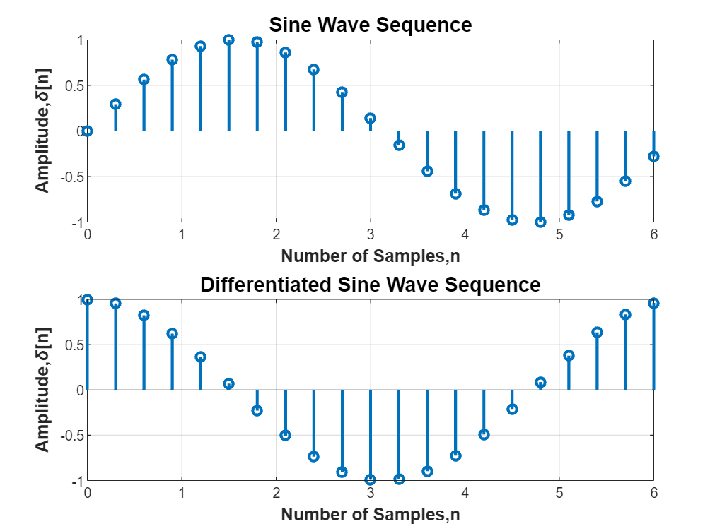

1. **To perform four operations on any Generated Sequences (Operations on Dependent and Independent Variables):**
2. **Addition**
3. **Multiplication**
4. **Amplitude Scaling**
5. **Amplitude Shifting**

clc

clear all

close all

syms t;

t1=0:0.3:2*pi;

subplot(2,2,1);

x=sin(t)+cos(t);

stem(t1, subs(x,t1),'linewidth',2);

set(gca,'fontsize',13,'fontweight','bold');

xlabel('Number of samples,n','fontsize',11,'fontweight','bold');

ylabel('Amplitude','fontsize',11,'fontweight','bold');

title('Sin(t) + Cos(t)','fontsize',14);

grid on;

subplot(2,2,2);

x=sin(t)*cos(t);

stem(t1, subs(x,t1),'linewidth',2);

set(gca,'fontsize',13,'fontweight','bold');

xlabel('Number of samples,n','fontsize',11,'fontweight','bold');

ylabel('Amplitude','fontsize',11,'fontweight','bold');

title('Sin(t) * Cos(t)','fontsize',14);

grid on;

subplot(2,2,3);

x=sin(t);

stem(t1, 2*subs(x,t1),'linewidth',2);

set(gca,'fontsize',13,'fontweight','bold');

xlabel('Number of samples,n','fontsize',11,'fontweight','bold');

ylabel('Amplitude','fontsize',11,'fontweight','bold');

title('Amplitude Scaling by 2','fontsize',14);

grid on;

subplot(2,2,4);

x=sin(t-pi);

stem(t1, subs(x,t1),'linewidth',2);

set(gca,'fontsize',13,'fontweight','bold');

xlabel('Number of samples,n','fontsize',11,'fontweight','bold');

ylabel('Amplitude','fontsize',11,'fontweight','bold');

title('Shifting Operation by \pi','fontsize',14);

grid on;

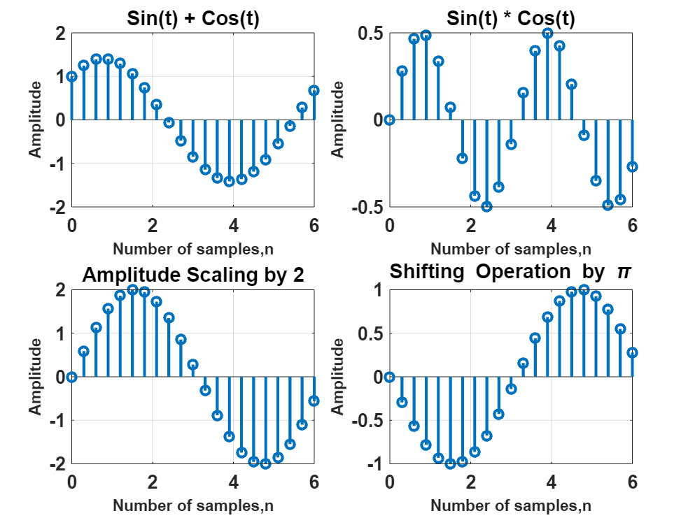

**OUTPUT VERIFICATION**

